**ANOVA & CORRELATION PROBLEMS**

Q1.

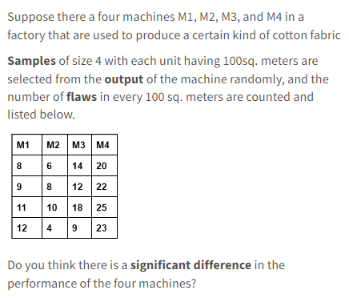

In order to determine if there is a significant difference in the performance of the four machines, we can perform a one-way ANOVA (Analysis of Variance) test. This statistical test can be used to compare means of three or more groups and determine if there is evidence of statistically significant differences among the means.

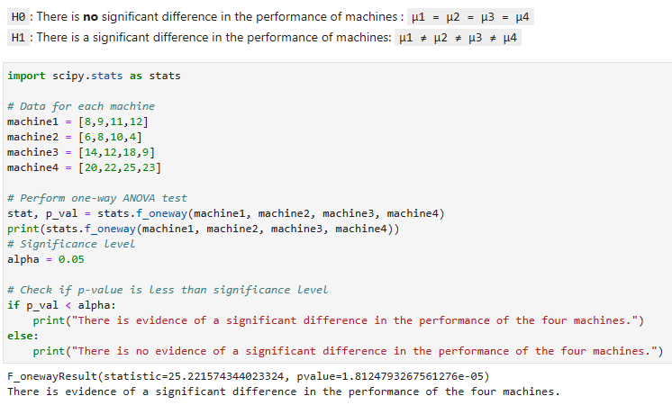

Q2.

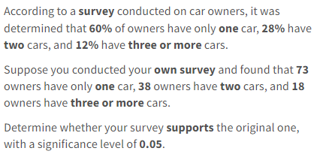

Here's we can do a Python implementation of a chi-squared goodness-of-fit test to determine if your survey supports the original survey results, with a significance level of 0.05:

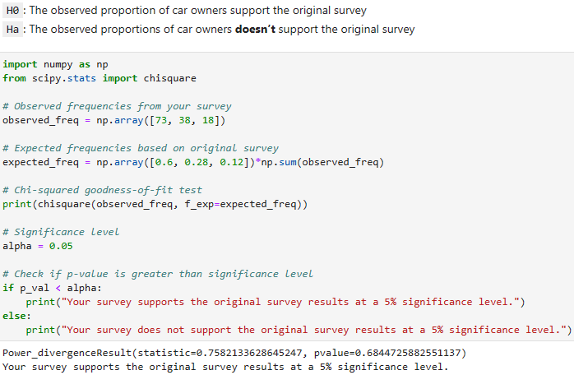

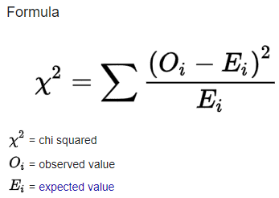

Q3.

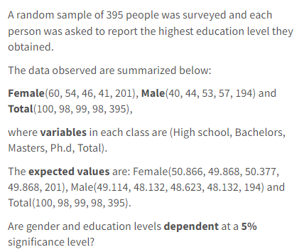

Here's an example of how you could perform a chi-squared test of independence in Python to determine if gender and education levels are dependent based on the given data

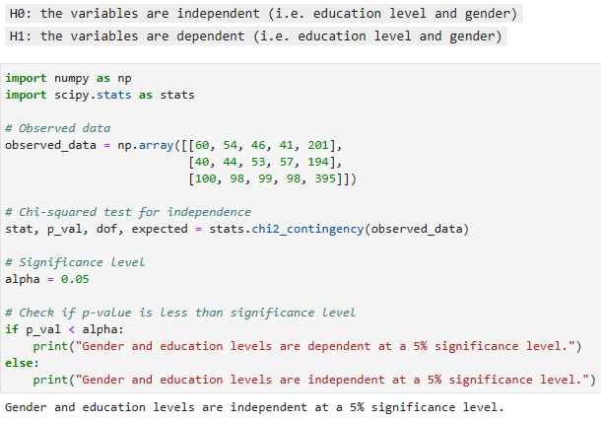

Q4.

Manual Solving for Chi Square

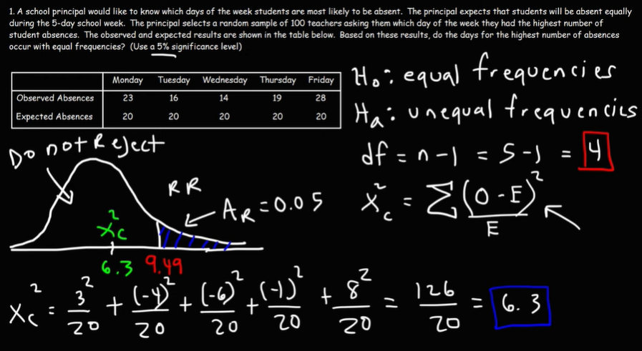

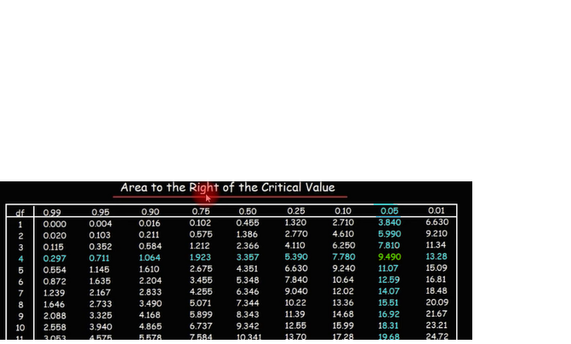

Q5.

